**Windows Navigation Diagram:**

In order to get feedback from students regarding the faculties and the courses BRAC University has decided to build an app named Course and Faculty review. When you first get into the app you will find the 2 options - Rate my Faculty, See Faculty Review. If you want to review a faculty, you need click on the Rate my Faculty option. After that first you will be asked to fill

up a form with your information. After submitting the form you need to enter the name of the faculty and click on search. If there is a match you will see a list of faculties with that name. Otherwise you will see a popup window saying No faculties found and a button to search again. From the list of faculties if you click on a name you will be taken to a form where you can rate and write reviews for that faculty. On submitting that form your review will be stored and you

will be taken to a thank you page. And in that page you will find a button to return to the home screen. By clicking the See Faculty review option you can see the ratings of a faculty. First you need to search the name in the same process and if there is a match you will again see a list of names. If you click on one of them you will see a screen with all the reviews and ratings for that faculty.

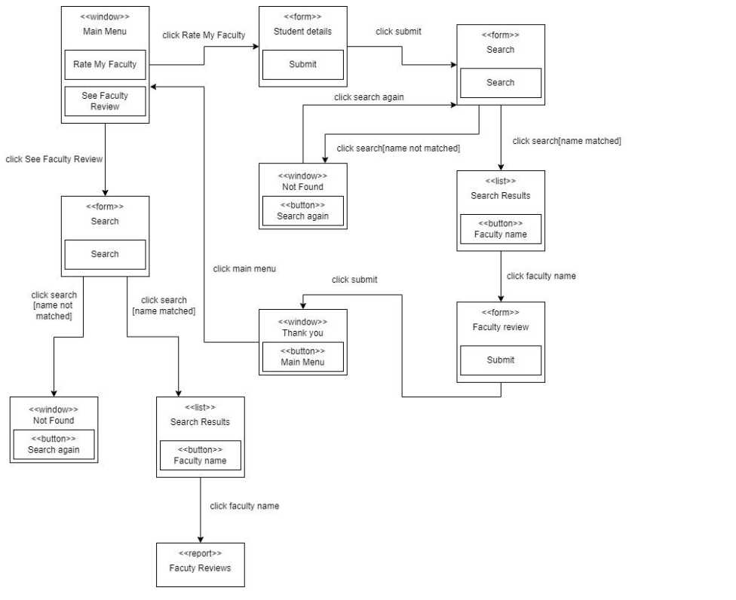

**Structure chart:**

Roamer is a watch brand from Switzerland and they want to calculate the total watch revenue of the R Line System Line up. In order to generate the watch revenue, initially the watch records are retrieved for all of the watches in the record file, where the records are also validated. The validated records are then used to calculate the net price. For calculating the net price, the cost price is initially calculated using the watch id, and materials information. From the

cost price, tax withheld is calculated using the tax rate for specific watch id and thus the net price of every watch is updated. Furthermore, process sales determines the total price for any watch, according to the order id and watch id. The orders are also verified by their order id and then classified into regular orders or bulk orders. For the regular order, the regular price is calculated and the regular invoice is returned. However for the bulk orders, a discount is retrieved, and then the discounted price is calculated from which the bulk invoice would be sent. Finally, after the total price is collected from the invoice, a checkout is printed of the total price. Draw a structured chart for the mentioned details.

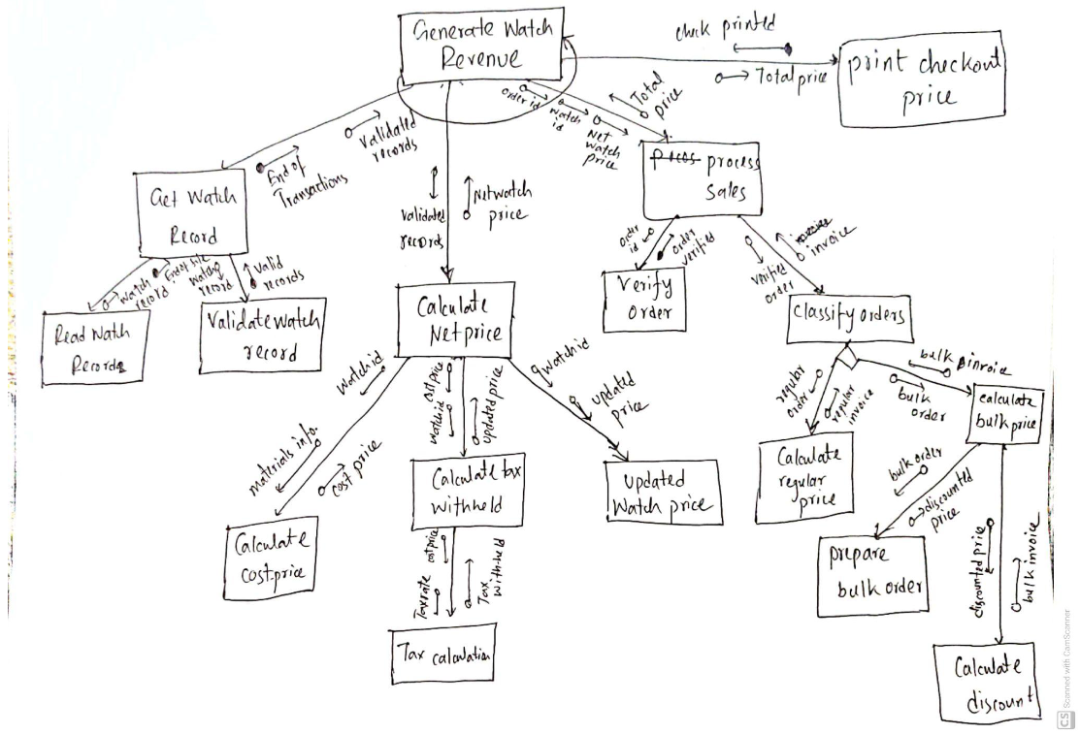

**Windows Navigation diagram:**

CineplexBD has recently launched an app called “Movie review” that allows viewers to rate and review movies currently being aired in theaters. When a viewer first enters the app, there are two options – Rate Movie, See Movie Rating.

In order to rate a movie, the viewer first needs to click on the “Rate Movie” button. Then the viewer is asked to fill up a form with their information. After filling up the form, the viewer clicks submit the form button and the viewer is redirected to another form where they need to enter the name of the movie and click on the search button. If there is a match, the viewer can see the hyperlink list of movies with that name. Otherwise, there appears a popup window that says “No movies found” and a button to search again. From the list of movies, if the viewer clicks on a movie, they are taken to a form where they can rate and write reviews for that movie. On submitting that form the rating is stored and the viewer is taken to a thank you page. In the thank you page, there is a button to return to the home screen.

Viewers can see the moving ratings and reviews by clicking the “See Movie Rating” button. The viewers fill up a form in the same process and click on the search button. After that, a hyperlink list of movies is returned. Clicking on the hyperlink generates a report containing all the reviews and ratings for that movie. Viewers have the option to search again if the search result returns nothing.

